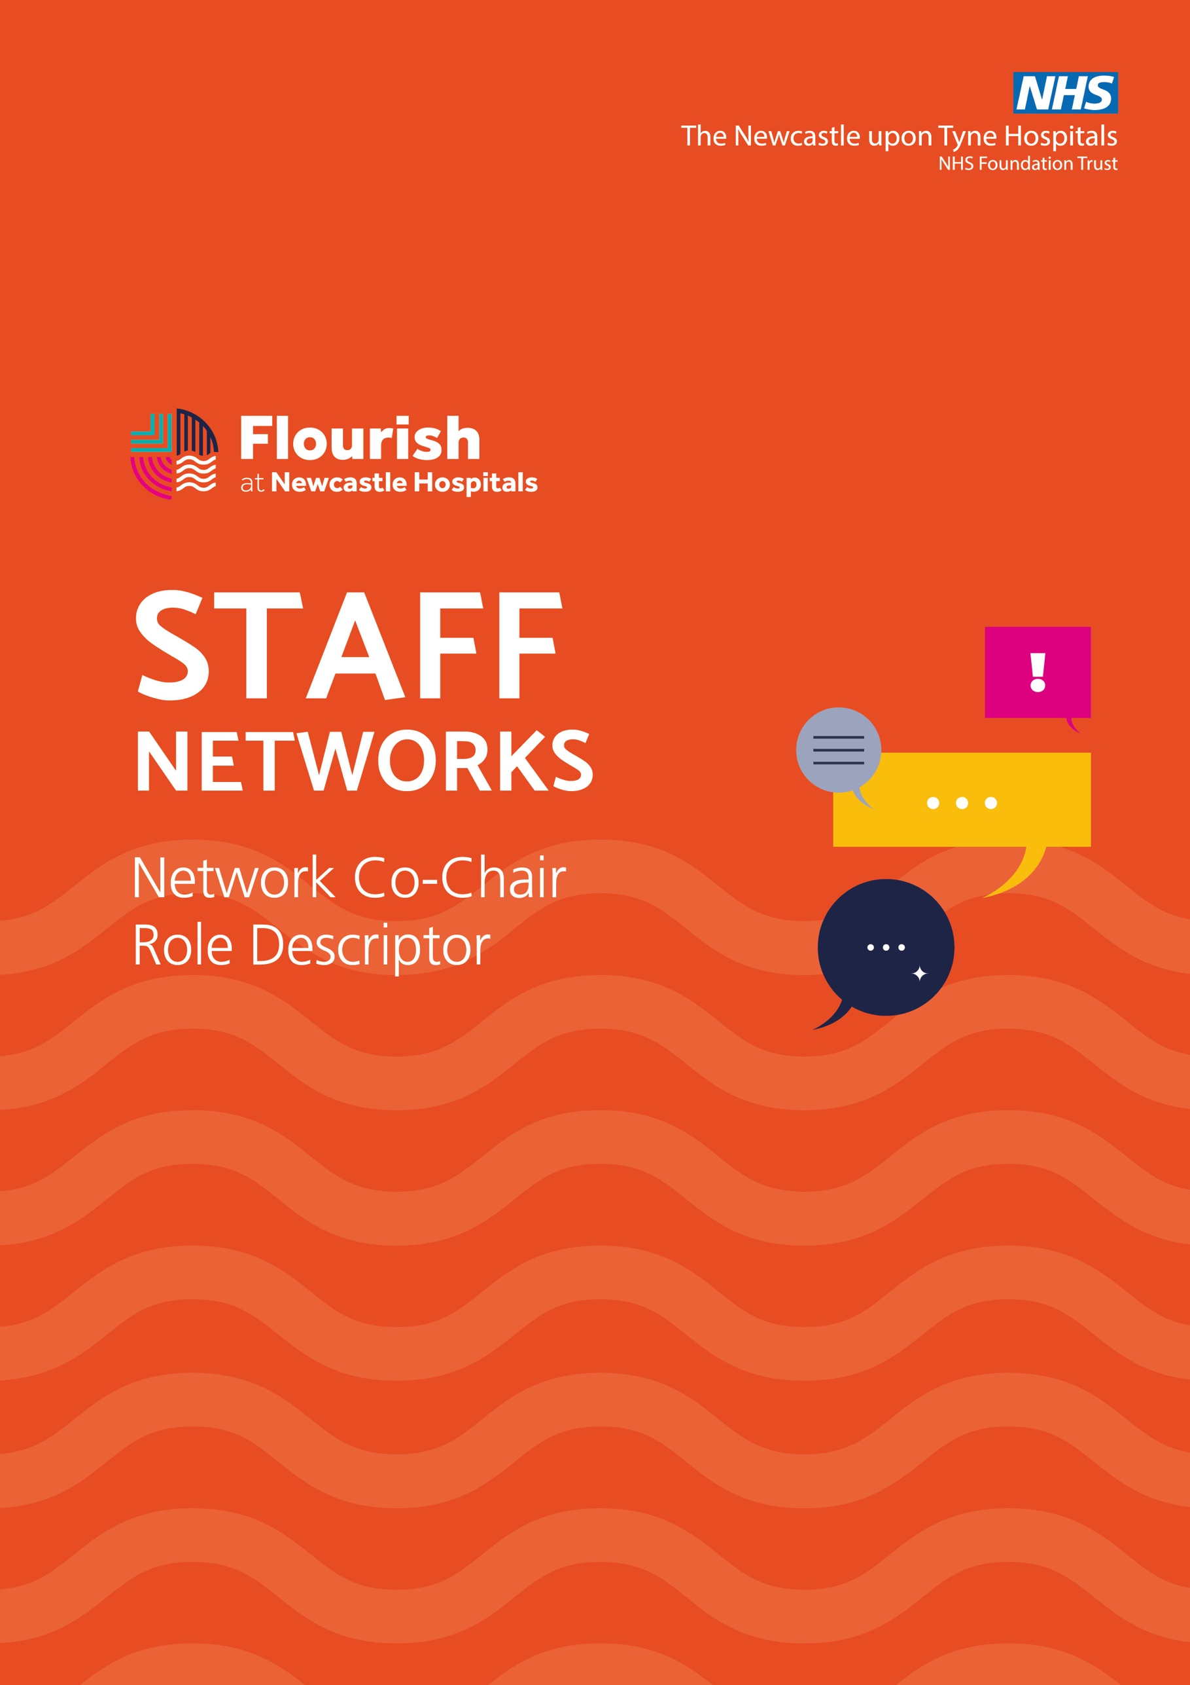

Together We Make a Difference!
Launched in 2014, our staff networks are pivotal to our Equality, Diversity and Inclusion agenda. They support staff, increase awareness and engagement and help to ensure we are as inclusive as possible. We recognise the value of our staff networks and promote them widely to encourage attendance. Any member of staff can join our staff networks to create an environment of support for all and we ask managers to enable time for attendance.
Each network group has two recognised Co-Chairs, supported by the EDI Team. We recognise that whilst being a Co-Chair is a voluntary role, there are specific responsibilities that take time to complete. Listed below are some of the role responsibilities along with our commitment as a Trust to support this essential function.
Allocation of Time and Support
This role is undertaken on a voluntary basis. In recognition of the additional demands both internally and through requests to contribute to the system, regional and national discussions the Executive Team has agreed to provide time to facilitate the work of the three staff networks - ENABLED, Pride and Race Equalities.
• Up to three days’ time per month between the Co-Chairs of each network to focus on
their staff network, event planning, progressing and supporting activity etc
• How the three days will be utilised and shared between the Co-Chairs will be left to their
discretion
• This time is in addition to that which is allocated for participating in the ‘routine’ staff
network meetings
• Support for the networks will be provided by the EDI Team.

Role of Co-Chairs
- Work with the EDI Team to support and encourage growing the membership of your staff network
- Meet with the EDI Team on a monthly basis to work in partnership to agree and facilitate an EDI Programme of Events around key diversity days.
- Proactively develop initiatives, events, and activities that reflect the network priorities, ensuring you include the network members in projects and activities.
- Agree and regularly review (every 12 months) a standing agenda for network meetings and ask for any items for consideration from the network membership.
- Attend and chair regular meetings with your staff network
- Ensure contributions are shared between Co-Chairs so at least one is present for each ‘routine’ meeting
- Liaise regularly with the Equality, Diversity, and Inclusion Managers to agree support required to record actions and ensure actions are shared with members who are unable to attend the meetings
- Attend and work in partnership to develop and deliver an annual awareness and education plan with support from Equality, Diversity and Inclusion Managers
- Attend regular regional network chairs meetings to facilitate collaborative working and share good practice. Bring learning and regional discussion back to the Staff network
- Help create a psychologically safe, positive and rewarding experience for members.
- Respect & understand confidentially as it applies within the Trust.
- Promote inclusion for all, recognising intersectionality and allies as well as those who share a particular characteristic.
- Treat all network members, other co-chairs, and staff with dignity and respect.
- Promote a positive contribution to organisational culture and support members to address concerns using Trust processes.
- Create a culture where members listen to each other's points of view, recognising that there may be disagreement and challenge any inflammatory or offensive language or behaviour in line with Trust policy.
Help any member of the network by signposting to appropriate support when requested. Consult with the EDI Team if an issue arises with individual members to ensure factual accuracy and appropriate support is provided. It is not the role of the staff network co-chairs (or other members) to ‘represent’ network members. If you are unsure what support is available ask for guidance from the Equality, Diversity and Inclusion Managers.

Role of Co – Chairs continued

- Advocate for and “be the voice” of the network and its members when needed, specifically attending senior engagement meetings as requested on behalf of the network.
- Work with all other staff network co-chairs to provide mutual support
to maximise the impact of the networks for those who may share multiple characteristics.
- Communicate with the network in an accessible way that avoids jargon.

